## Library Module – Shared Library

1. Create 3 files as below.
   * libapplication.c – will contain main() and will invoke functions in cal_utility.c

Ans:

* + cal_utility.c – will contain atleast 2 or more functions [ You may add definitions of the functions in this file ]

Ans:

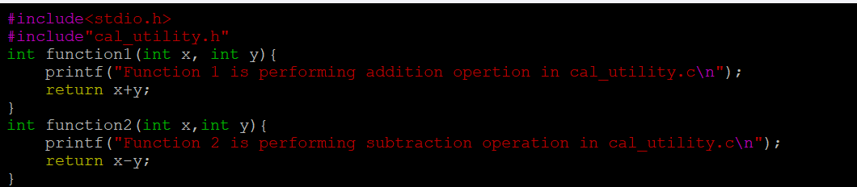

* + cal_utility.h – will contain the extern declarations/prototypes of the functions in cal_utility.c

Ans)

1. Refer the steps for shared library and create a shared library comprising of cal_utility.c,.h files

Ans: To create a shared library, we need to first compile cal_utility.c file using -FPIC option to create a.o file This .o file will form the shared library, to do that use gcc command with optionn -shared to create shared library as below. [Ensure that library name is prefixed with “lib” and extension as “.so”].

gcc -fPIC -c cal_utility.c

gcc -shared -o libcal_utility.so cal_utility.o

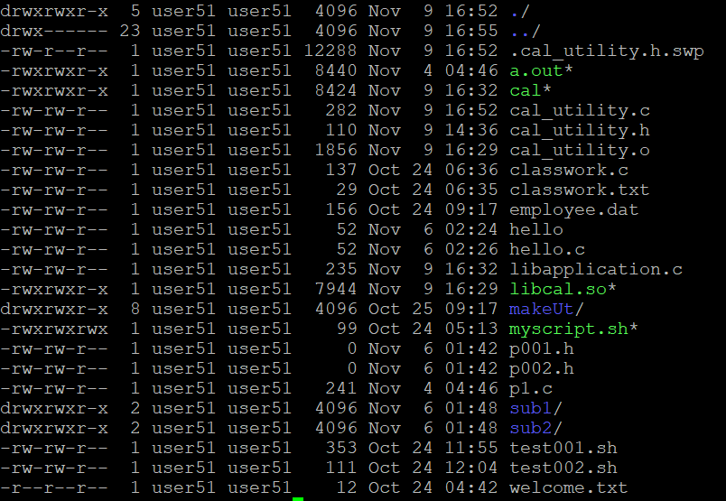

1. Create an executable using shared library.

Ans: gcc libapplication -L./ -lcal -o cal

1. Execute the application created step 3.

Ans: ./cal

